Multiple-choice section

Question 1 [5.1]

Tom has nine bags of frogs, with p frogs in each bag. He eats seven of these frogs. The total number of frogs that Tom has now can be written using algebra as:

A 9p – 7 B 9p + 7 C 9 + p – 7 D 9 + p + 7

Question 2 [5.1]

The sum of x and 12 is divided by 4. This can be written using algebra as:

A x + 3 B 12x  4 C  D + 12

Question 3 [5.1]

Ahmed has m marbles, Jasmine has 3 less marbles than Ahmed. Sunil has twice the number of marbles that Jasmine has. How many marbles does Sunil have?

A 2m+ 3 B 2(m – 3) C 2m – 3 D 

Question 4 [5.2]

Which of the following expressions has a constant term of 3?

A 3p + 2 B 3p2 C 5p – 3q D 5p + 3

Question 5 [5.2]

Which expression below matches the instruction given?

*Choose a number and multiply it by five, subtract another number, then add 3.*

A 5m – n – 3 B 5 + m – n + 3 C 5m – n + 3n D 5m – n + 3

Question 6 [5.6]

A like term for 6art is:

A 6rat B 6ar C 6at D 6rt

Question 7 [5.6]

Which of the following is obtained when 7p + 12 + 11p – 9 is simplified?

A 21p B 30p + 9 C 18p + 3 D 18p – 3

Question 8 [5.3]

Choose the correct algebraic rule given for this sentence:

*To get y, find the square root of x then add 4*.

A  B  C  D 

Question 9 [5.4]

For the rule l = 6m + 2, where m = 4, l is equal to:

A 12 B 26 C 66 D 27

Question 10 [5.4]

A rule is given as P = 6(n – 1). Which pair of values below do not fit this rule?

A n = 6, P = 30 B n = 5, P = 24 C n = 11, P = 59 D n = 12, P = 66

Question 11 [5.5]

The general rule for the following pattern is:

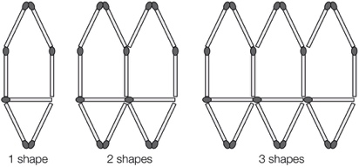

A m = 6s + 2 B m = 6s + 1 C s = 6m – 2 D s = 6m – 1

Question 12 [5.7]

Which quadrant does the point (-5, -1) lie in?

A Quadrant 1 B Quadrant 2 C Quadrant 3 D Quadrant 4

Question 13 [5.8]

For the table, what is the rule linking x and y?

|  |  |  |  |  |
| --- | --- | --- | --- | --- |
| x | 14 | 20 | 12 | 32 |
| y | 6 | 12 | 4 | 24 |

A y = x – 8 B x = y – 8 C x + y = 18 D y = 

Question 14 [5.9]

Which of the following graphs shows D and C having the same weight?

A B C D

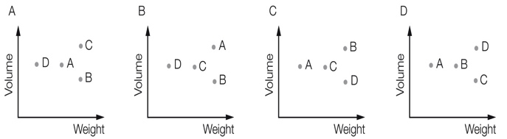

Multiple-choice total marks: \_\_\_\_ / 14

Short answer section

Question 15 3 marks [5.7, 5.8]

Use words from the list below to complete the following sentences.

x-axis formula point graph relationship y-axis origin

(a) The point (3, 0) is located on the \_\_\_\_\_\_\_\_\_\_\_\_\_ .

(b) The equation y = 4x + 1 is a linear \_\_\_\_\_\_\_\_\_\_\_\_\_\_\_\_\_\_\_\_ between the x and the y values.

(c) The point (0, 0) is the \_\_\_\_\_\_\_\_\_\_\_\_\_\_\_\_\_\_ of the Cartesian plane.

Question 16 2 marks [5.2]

What is a mathematical expression? Give an example.

Question 17 2 marks [5.1]

Write the following in simplest form using algebra.

(a) 10 is added to the product of s and t.

(b) A number is multiplied by itself then divided by 3.

Question 18 4 marks [5.1, 5.6]

Michael has p pineapples. Sam has four more pineapples than Michael. Tran has three times as many pineapples as Michael. Use algebra to write:

(a) the number of pineapples that Sam has

(b) the number of pineapples that Tran has

(c) the number of pineapples that they have altogether. (Simplify your answer.)

Question 19 3 marks [5.1]

At a farm there are x chickens, y sheep and z cows.

(a) How many legs are there on these animals altogether?

(b) If 2x + y = 12, find a set of possible values for x and y.

Question 20 2 marks [5.2]

Write the expression for the following instructions:

Choose a number, square it, then choose another number and divide it by 2, then multiply the  
sum of the two by 3.

Question 21 3 marks [5.2]

A protractor costs $g and a pen costs $h.

(a) Define g and h.

(b) Nine protractors cost the same price as five pens. Write an equation for this situation.

Question 22 3 marks [5.2]

A box of mass 4 kg contains 40 tins. The total mass of the box and tins is 34 kg.

(a) Write a pronumeral to represent the mass of one tin.

(b) Write an equation to represent the total mass of the box.

Question 23 5 marks [5.3]

If y is equal to 2 times the sum of x and 5.

(a) Draw a flowchart for this rule.

(b) Write the rule using algebra.

(c) Complete the following table of values for the rule.

|  |  |  |  |  |
| --- | --- | --- | --- | --- |
| x | 4 | 5 | 6 | 10 |
| y |  |  |  |  |

Question 24 2 marks [5.3]

The following table of values has only the y values filled in. Use the flowchart to complete the table (remember to work backwards).

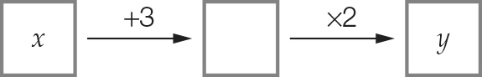

|  |  |  |  |  |
| --- | --- | --- | --- | --- |
| x |  |  |  |  |
| y | 8 | 28 | 60 | 48 |

Question 25 3 marks [5.3]

Write each of the following rules in simplest form using algebra.

(a) Subtract six from p, then divide the result by five to find y.

(b) To find y, subtract b from 50.

(c) To find y, multiply x by itself then triple the result.

Question 26 2 marks [5.3]

Write the algebraic rule shown by the following flow chart.

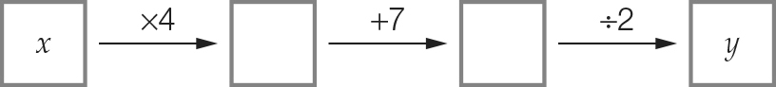

Question 27 4 marks [5.3]

Chris spent $200 on materials to make toys. Each toy he produced cost him $12, so for one toy to be produced it cost $200 + $12 × 1 = $212.

(a) Using this information, fill in the table below.

|  |  |  |  |  |
| --- | --- | --- | --- | --- |
| Number of toys, n | 10 | 12 | 20 | 100 |
| Cost to produce the toys, C |  |  |  |  |

(b) Write a rule for the cost of producing the toys.

Question 28 2 marks [5.4]

Answer true or false for each of the following.

(a) If you substitute a = 2 into b = 4(a + 6) you get b = 32.

(b) If you substitute t = 5 into C = 8t – 30 you get C = 55.

Question 29 2 marks [5.4]

Use the rule n =  to complete the table of values below.

|  |  |  |  |  |
| --- | --- | --- | --- | --- |
| m | 20 | 25 | 15 | 40 |
| n |  |  |  |  |

Question 30 2 marks [5.4]

The distance (d metres) an object will fall in t seconds can be calculated using the formula d = 5t2.

How far will the object fall in 1 second?

Question 31 6 marks [5.6]

Here is a matchstick pattern of shapes.

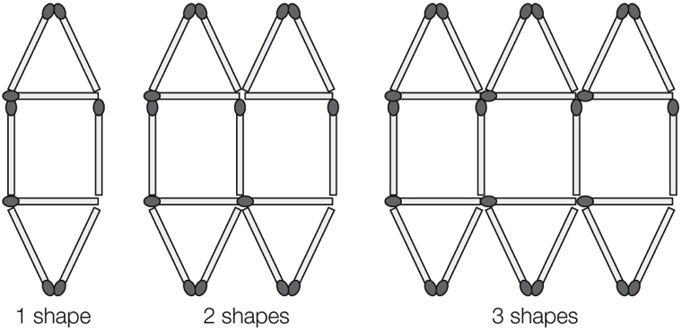

(a) Complete the table below.

|  |  |  |  |  |  |
| --- | --- | --- | --- | --- | --- |
| Number of shapes, S | 1 | 2 | 3 | 4 | 5 |
| Number of matches, M |  |  |  |  |  |

(b) Find a general rule that connects the number of matches to the number of shapes.

(c) Use your rule to find the number of matches needed to build 30 shapes.

Question 32 6 marks [5.6]

Simplify each expression where possible by collecting like terms.

(a) 43m – m (b) 12xy – 9yx

(c) 4a2 + 3 + 5a2 (d) 3x – 6x + 4

(e) 9p + 7q + 4p – 6q (f) 5m + 12 + 3n + m – 8

Question 33 2 marks [5.6]

Rachel earns $v each week and spends $w of this amount. Write an expression to represent how much money she will have after 8 weeks.

Question 34 4 marks [5.7]

Write the coordinates of each point below.

|  |  |
| --- | --- |
| PM7_SmB_5_02sbT | A \_\_\_\_\_\_\_\_\_  B \_\_\_\_\_\_\_\_\_  C \_\_\_\_\_\_\_\_\_  D \_\_\_\_\_\_\_\_\_ |

Question 35 8 marks [5.8]

(a) Plot the following points on the number plane and draw a straight line passing through all points.  
(-1, -2), (0, 1), (1, 4), (2, 7)

|  |  |  |  |  |  |  |  |  |  |  |  |
| --- | --- | --- | --- | --- | --- | --- | --- | --- | --- | --- | --- |
| PM7_SmB_5_03sbT | (b) Summarise the set of points in the table below.   |  |  |  |  |  | | --- | --- | --- | --- | --- | | x |  |  |  |  | | y |  |  |  |  |   (c) Write a rule linking the x and y values.  (d) Write the coordinates of another point on the line. |

Question 36 3 marks [5.9]

The point graph shows the populations and areas of France, India and Australia. (Note: Australia has a larger area than France or India. India has a higher population than France and Australia.)

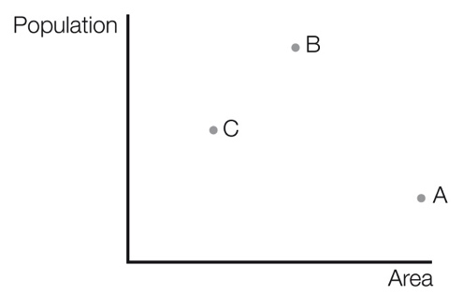

Write the country represented by each point.

A: \_\_\_\_\_\_\_\_\_\_\_\_\_\_\_\_\_\_ B: \_\_\_\_\_\_\_\_\_\_\_\_\_\_\_\_\_\_ C: \_\_\_\_\_\_\_\_\_\_\_\_\_\_\_\_\_\_

Question 37 6 marks [5.9]

Nathan travelled to a stadium to watch a football match. On the way home, he stopped to visit a friend then continued on his way home. This information is shown on the travel graph below.

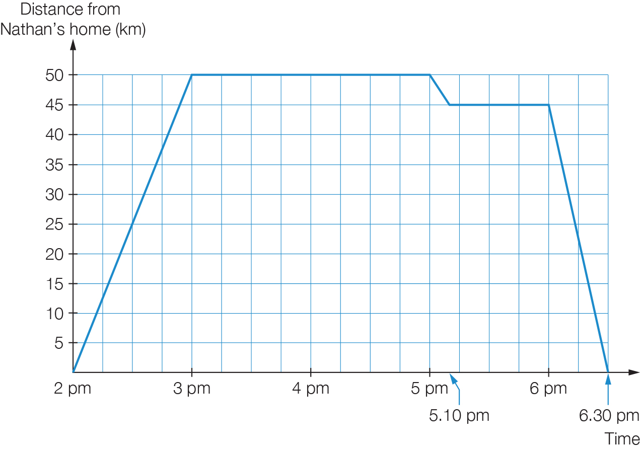

(a) How much time did the football match take?

(b) How much time was spent on travelling?

(c) What was the total distance travelled?

(d) At what speed was Nathan travelling on his way home from his friend’s place?

Short answer total: \_\_\_\_\_\_\_\_\_ / 79

Extended answer section

Question 38 4 marks [5.2]

Shirin has two jobs. The first job pays $12 per hour and the second job pays $8 per hour. Let E be the amount she earns in one week, let m be the number of hours she works at the first job in a week and let n be the number of hours she works at her second job in a week.

(a) Write an equation for the amount of money Shirin earns in a week.

(b) In one week, Shirin earned $76. Give two possible sets of hours (whole numbers only) that Shirin could have worked at her jobs in order to earn a total of $76.

Question 39 5 marks [5.3]

Madelyn has savings in an account. She deposits an additional $900 then uses half of her total savings to buy a car. She then spends $300 on car insurance.

(a) Draw a flowchart to show the amount Madelyn has spent (y).  
Let x be the initial amount of Madelyn’s savings.

(b) Write an algebraic rule for the flowchart.

(c) Use the rule to find how much Madelyn spent if she had $6000 in her savings initially.

Question 40 6 marks [5.4]

Bob is building a timber deck. He needs 10 nails for every board and an extra 40 nails.

(a) Write the formula, using algebra, to represent the number of nails required. (Let b be the number of boards and n be the number of nails.)

(b) Once the boards have been laid, Bob stains the deck. One can of stain will cover 80 boards. Write a formula, using algebra, to represent the number of cans required. (Let b be the number of boards and C be the number of cans.)

(c) Use your formulas from (a) and (b) to find the number of nails and cans of stain that Bob will need for 160 boards.

Question 41 5 marks [5.6]

I open a bank account. In the first week I deposit $x. Each week after that, I deposit $3 more than the previous week.

(a) Write an expression (in simplest form) for the amount of my fifth deposit.

(b) How much money did I deposit in the first 5 weeks altogether?

(c) How much money do I have in my account after 5 weeks if my initial deposit was $12?

Question 42 5 marks [5.8]

(a) Plot the points (1, 1) and (2, 4) on the Cartesian plane below.

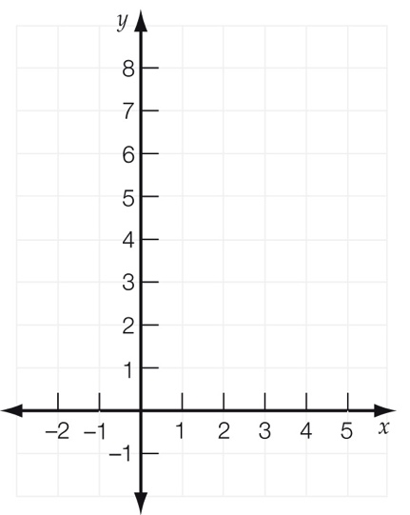

(b) Draw a straight line passing through these points.

(c) Draw a line parallel to this line, which passes through the point (3, 2).

(d) Find the value of y if (4, y) is on the line you drew in (c).

Extended answer total:\_\_\_\_\_\_\_\_\_/25

TOTAL test marks: \_\_\_\_\_\_\_ / 118